22nd IEEE International Conference on Industrial Informatics (INDIN), August 17-20, 2024, Beijing, BJ, China

Special Session on

“Robust and Trustworthy Perception, Planning and Control of Connected and Autonomous Vehicles”

Organized by
Principal Organizer(s): (Names with email address and affiliation)

Yang Li, Hunan University, lyxc56@gmail.com
Yougang Bian, Hunan University, byg10@foxmail.com
Ye Li, Central South University, yelicsu@csu.edu.cn
Dachuan Li, Southern University of Science and Technology, dachuanli86@gmail.com
Ming Gao, Hunan University, gaoming@hnu.edu.cn

Call for Papers
Theme: (100 words)

Connected and autonomous vehicles represent a transformative evolution in the automotive industry, integrating cutting-edge AI, computer vision, optimization, and control technologies to enhance traffic safety, efficiency, and the overall driving performance. In particular, robust and trustworthy perception, planning, and control are essential technologies of developing safe and efficient connected and autonomous vehicles. Specifically, robustness involves dealing with uncertainties in the real-world driving scenarios such as multimodal sensor fusion, adverse weather/environmental conditions, and corner/unseen/hard cases. Trustworthiness ensures that the autonomous system can operate reliably and safely, which mainly focuses on transparency, accountability, fairness, ethical considerations, and reliability, etc.

Topics of interest include, but are not limited to:
- Multimodal sensing fusion
- Interaction-aware multimodal motion prediction
- End-to-end interpretable prediction and planning
- Robust decision-making and planning under uncertainty
- Trustworthy interaction-aware decision-making and planning
- Reinforcement learning-based decision, planning, and control
- Robust cooperative control for nonlinear multi-vehicle platooning
- Reachability-based safety assurance within the planning framework
- Simulation and test of autonomous systems

Potential Contributing Authors (names and emails):
10-20 Names with email and affiliation address

- Yang Li, Hunan University, lyxc56@gmail.com
- Yougang Bian, Hunan University, byg10@foxmail.com
- Ye Li, Central South University, yelicsu@csu.edu.cn
- Bin Pan, Central South University, bingpan@csu.edu.cn
- Yuntao Shi, Central South University, yuntaoshi@csu.edu.cn
- Chang Ge, Central South University, gechang@csu.edu.cn
- Xiaowei Wang, Hunan University, xiaoweiwang@hnu.edu.cn
- Ming Gao, Hunan University, gaoming@hnu.edu.cn
- Pengwen Dai, Sun Yat-sen University, daipengwen@iie.ac.cn.
- Jingjia Teng, Hunan University, tengjingjia@foxmail.com
- Haoyang Dong, Hunan University, 318691209@qq.com
- Yafeng Yin, University of Michigan, yafeng@umich.edu
- Dachuan Li, Southern University of Science and Technology, dachuanli86@gmail.com

Potential Reviewers (names and emails):
10-20 Names with email and affiliation address
- Yang Li, Hunan University, lyxc56@gmail.com
- Yougang Bian, Hunan University, byg10@foxmail.com
- Xiaowei Wang, Hunan University, xiaoweiwang@hnu.edu.cn
- Ming Gao, Hunan University, gaoming@hnu.edu.cn
- Ye Li, Central South University, yelicsu@csu.edu.cn
- Baojie Wang, Chang’an University, wangbj2@163.com
- Jaeyoung Lee, Central South University, jaeyoung@knights.ucf.edu
- Yi He, Wuhan University of Technology, heyi@whut.edu.cn
- Wenjia Niu, Beijing Jiaotong University, niuwj@bjtu.edu.cn
- Pengwen Dai, Sun Yat-sen University, daipengwen@iie.ac.cn
- Dachuan Li, Southern University of Science and Technology, dachuanli86@gmail.com

IES Technical Committee Sponsoring the Special Session (if any):

Yang Li, received her Ph.D. degree from Tsinghua University, China, in 2020. She is now working as an Assistant Professor at Hunan University, China. She worked as a postdoc in Electrical Engineering, Mathematics, and Computer Science at Delft University, the Netherlands, from 2020 to 2022. Her current research interests include environmental perception, motion prediction, situational analysis, decision-making and planning, control of intelligent and automated vehicles, and applications of deep learning and safe reinforcement learning in automated driving.

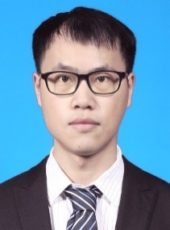
Yougang Bian, received the B.E. and Ph.D. degrees from Tsinghua University, China in 2014 and 2019, respectively. He was a visiting scholar with University of California at Riverside from 2017 to 2018. He is now with Hunan University, in China. His research interests include cooperative control and intelligent control with applications to connected automated vehicles. He is a recipient of the Outstanding Survey Paper Award at IEEE ITS Mag., the Best Paper Award at IEEE IV’17, and the Young Professional Excellent Paper Award at China SAECCE 2022.
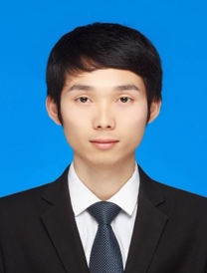
Ye Li received the B.Eng. degree and Ph. D. degree in transportation planning and management from Southeast University, Nanjing, China in 2014 and 2019. He is currently working in School of Traffic and Transportation Engineering, Central South University in Changsha, China, as an associate professor. His research interests include connected and automated vehicles, traffic safety and intelligent transportation system.

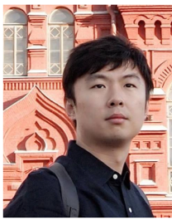
Dachuan Li (Member, IEEE) received his Ph.D. in control science and engineering from Tsinghua University (2015), China. He is currently an assistant professor (research track) at the Research Institute of Trustworthy Autonomous Systems, Southern University of Science and Technology, China. He was a postdoctoral researcher at California PATH and Institute of Transportation Studies, University of California, Berkeley from 2016 to 2018. His research interests include autonomous driving vehicles, trustworthy autonomous systems, decision-making and motion planning.

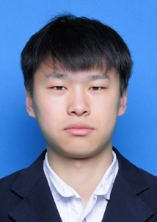
Ming Gao received the M.S. and Ph.D. degrees in vehicle operating engineering from the Jilin University, Changchun, China, in 2017 and 2020, respectively. He is currently a Research Associate Professor of Automotive Engineering with Hunan University, Changsha, China. His research interest includes autonomous driving, trajectory prediction and object detection.

